**Name: Session:**

**Programming II**

**Lab Exercise 2/20/2024**

1. The Yukon Widget Company manufactures widgets that weigh 9.2 pounds each. Create an application that calculates how many widgets are stacked on a pallet, based on the total pallet weight. The user should be able to enter how much the pallet weighs alone (the tare weight) and how much it weighs with widgets stacked on it (the gross weight). The user should click a button to display the number of widgets stacked on the pallet.

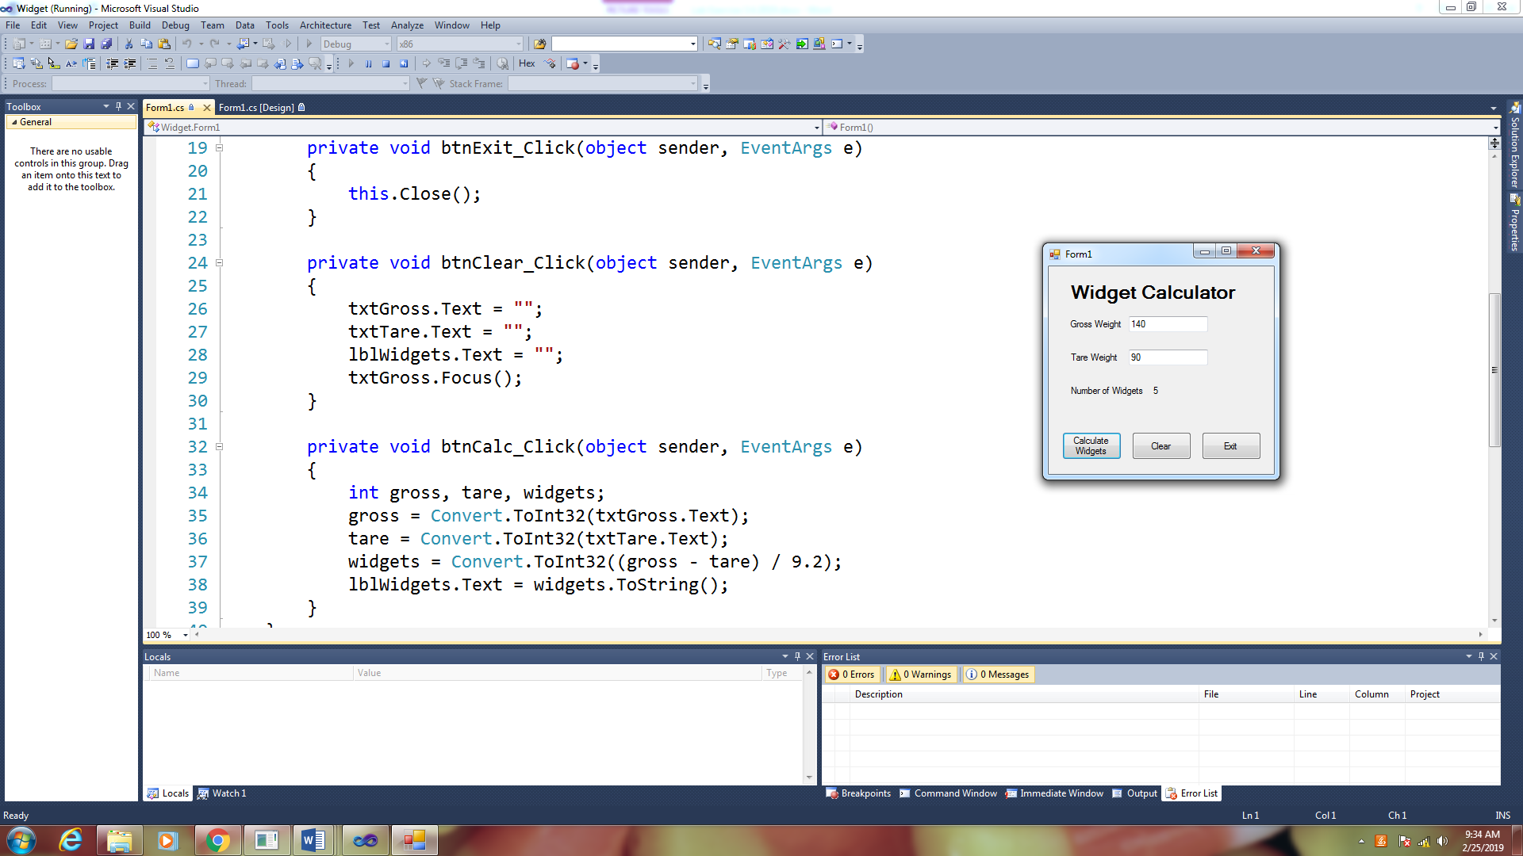

1. Create an application that converts U.S. Dollars into pounds, euros, and yen. Use the following conversion factors.

1 dollar = 0.88 Euros

1 dollar = 0.76 Pound Sterling

1 dollar = 110.81 Japanese Yen

In your code consider using named constants. For example:

const double dblYEN_FACTOR = 110.81;

const double dblEURO_FACTOR = 0.88;

const double dblPOUND_FACTOR = 0.76;

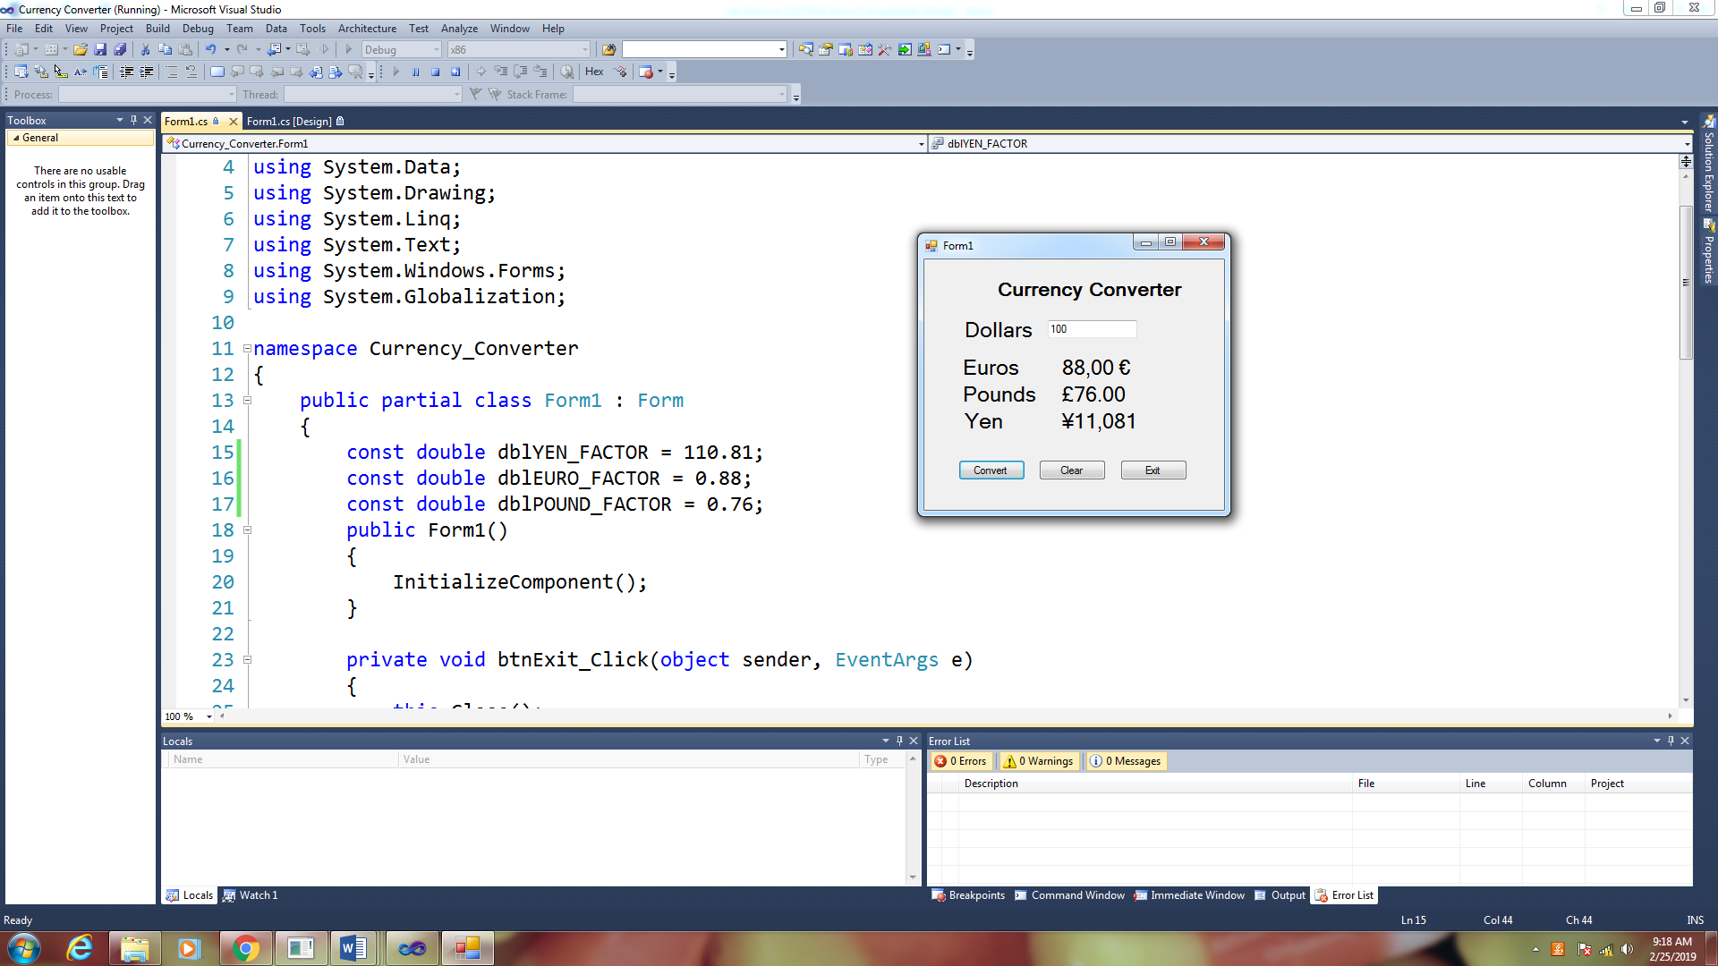

In order to use the international monetary symbols, we will need to add the Globalization Library and add a second parameter to the toString method.

Add the following Library

using System.Globalization

Modify your toString(“C”) method to the following:

lblEuros.Text = euros.ToString("c", CultureInfo.CreateSpecificCulture("de-DE"))

lblPounds.Text = pounds.ToString("c", CultureInfo.CreateSpecificCulture("en-GB"))

lblYen.Text = yen.ToString("c", CultureInfo.CreateSpecificCulture("ja-JP"))

1. A county collects property taxes based on the assessed value of the property, which is 60% of the property’s actual value (aka Market value). If an acre of land is valued at $10,000, its assessment value is $6,000. The property tax is determined by the mil rate (amount of tax per $1,000 of assessed value). If the mil rate was $6.40 then the tax for this property would be $38.40. Create an application that displays the assessment value and property tax when the user enters the actual value. If the actual value is $100,000 then the assessment value should be $60,000 and the property tax would be $384.00.

1. Joe’s Pizza Palace needs an application to calculate the number of slices a pizza of any size can be divided into. The application should do the following.
2. Allow the user to enter the diameter of the pizza in inches
3. Calculate the number of slices that can be cut from the pizza that size
4. Display a message that indicates the number of slices

To calculate the number of slices that can be cut from the pizza, you must know the following facts:

* Each slice should have an area of 14.125 square inches
* To calculate the number of slices, divide the area of the pizza by 14.125
* Area = πr2

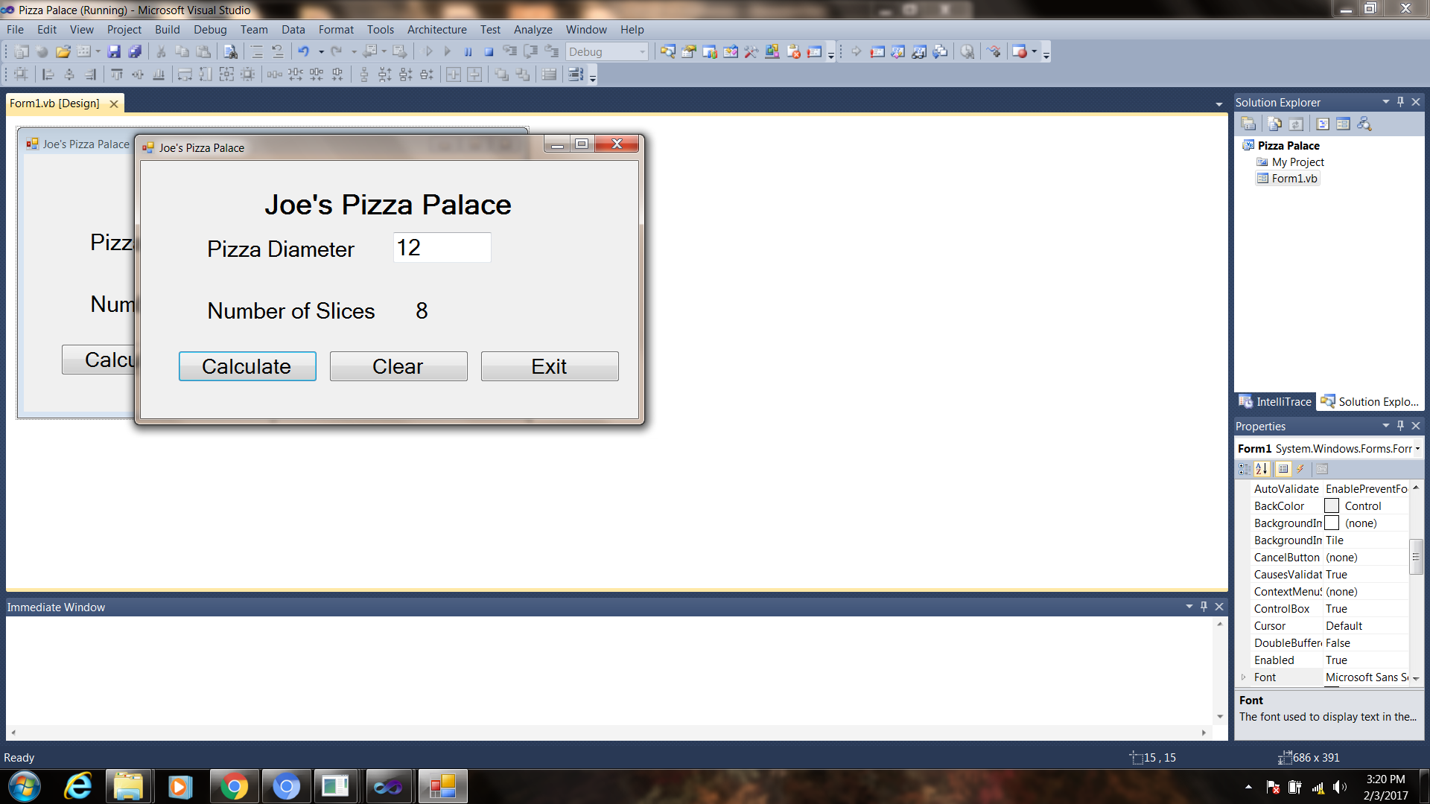

**When you have completed problem 1 - 4, submit their source code as a screen shot of your applications. Attach these to this sheet and turn in.**